

|  |  |  |
| --- | --- | --- |
|  | Available online at [www.sciencedirect.com](http://www.elsevier.com/locate/fss) |  |
|  |
| [Fuzzy Sets and Systems](http://dx.doi.org/10.1016/j.fss.2013.11.011) 239 (2014) 91–103 |
| [www.elsevier.com/locate/fss](http://www.elsevier.com/locate/fss) |

A method for deriving order compatible fuzzy relations from convex fuzzy partitions

Sandra Sandri∗, Flávia Toledo Martins-Bedê

*Brazilian National Institute for Space Research (INPE), Av. dos Astronautas, 1758, S.J. Campos, S.P., Brazil*

Available online 7 December 2013

**Abstract**

We address a special kind of fuzzy relations capable of modeling that two elements in the universe of discourse are similar to the extent that they are close to each other with respect to a given total order. These order compatible fuzzy relations are reflexive and symmetric but not necessarily *T*-transitive. We address the requirements to construct such relations from a large class of fuzzy partitions that obey some requirements from the fuzzy sets in the partition, such as convexity, that are useful but not severely constraining. We also propose a new method to obtain those fuzzy relations from these partitions.

© 2013 Elsevier B.V. All rights reserved.

*Keywords:* Similarity relations; Fuzzy relations; Fuzzy partitions; Total order; *T*-indistinguishable operators

**1. Introduction**

Several means can be devised to create fuzzy relations that somehow model the concept of similarity for use in applications. The user can enter the relation directly using a look-up table, when the application domain is discrete. In problems involving continuous domains, the relation can be obtained by choosing a family of parametrized relations, whose parameters are learnt from data or directly specified. A more user-friendly possibility consists in deriving the fuzzy relation out of a finite collection of fuzzy sets. The fuzzy sets themselves can be easily elicited from the user or learnt directly from the data. The present work addresses the problem of obtaining relations from fuzzy sets for applications in which the notion of similarity between two elements of a domain is based on their closeness on that domain.

In classical set theory, the notion of similarity between elements of a given domain can be modeled using two formalisms: a partition (a collection of non-intersecting sets covering the domain) and an equivalence relation (a reflexive, symmetric and transitive relation). The two formalisms are equivalent: from a given partition, one determines a unique equivalence relation and vice versa.

In the fuzzy framework, a fuzzy partition **A** on a given domain *�* is usually referred to as a collection of fuzzy sets of *�* at least covering (in some way) the domain. Several specific kinds of fuzzy partitions exist in the literature (see e.g. [20]) and they are all capable of capturing that two elements with positive membership degrees to a given In what regards modeling similarity by means of fuzzy relations, the most well-established approach is the one that fuzzy subset *Ai* ∈ **A** are somewhat related, thus modeling a weak notion of similarity.

requires a fuzzy relation to be reflexive, symmetric and to obey *T*-transitivity, the fuzzy counterpart of transitivity.

∗ Corresponding author. Tel.: +55 12 32086852.

*E-mail addresses:* [sandra.sandri@inpe.br](mailto:sandra.sandri@inpe.br) (S. Sandri), [flavinha@lac.inpe.b](mailto:flavinha@lac.inpe.br)r (F.T. Martins-Bedê).

0165-0114/$-see front matter © 2013 Elsevier B.V. All rights reserved.   
<http://dx.doi.org/10.1016/j.fss.2013.11.011>

92 *S. Sandri, F.T. Martins-Bedê / Fuzzy Sets and Systems 239 (2014) 91*–*103*

Indeed, *T*-transitivity plays the same role of transitivity in crisp relations; relations obeying it are thus adequate to model similarity in the fuzzy framework as equivalence relations do in the crisp counterpart.

*T*-transitivity is however ill-suited to deal with a notion of similarity in which two elements are similar to the extent that they are close to each other in the domain in which they are defined. For example, let us consider a relation that models the concept of “sweetness’’ [16]. Let *�* = {*�*1*, �*2*, �*3} stand for the number of spoons of sugar to be poured into a cup of coffee, with *�*1 *< �*2 *< �*3. As *�* is ordered, it is natural to expect that the similarity between the elements of the pair (*�*1*, �*3) is smaller than that existing between either (*�*1*, �*2) or (*�*2*, �*3) (see [16,22]). In this case, transitivity does not play a role, as the issue is more related to the notion of a total order than of an equivalence relation. Tversky [28] brings a deep discussion on how similarity is perceived by human beings and questions the use not only of transitivity, but also of reflexivity and symmetry. In the specific context of fuzzy relations, several authors addressed the inadequacy of *T*-transitivity (see e.g. [5,12,22]).

In previous works [7,11,17,10], we have dealt with a real-world problem using fuzzy relations for which transitivity does not play a role. The relations used in these works are reflexive, symmetric and obey an extra property: two numbers are similar to the extent that they are close to each other with respect to the Euclidean distance [9] (see also [18,23]). Obtaining these relations is rather difficult, which contrasts with the ease with which fuzzy partitions can be elicited. This paper aims at obtaining this type of relation from collections of fuzzy sets and is an extension to a preliminary work on the subject, presented in [21].

The transformations between a collection of fuzzy sets and *T*-transitive relations, defined on the same domain, have been established by *Representation Theorem* [29] (see also [24,25,4]). This problem has also been addressed when transitivity is modeled using other operators than *T*-norms (see e.g. [13]). However, the transformation between fuzzy partitions and fuzzy relations in which similarity is based in closeness on an ordered domain, as described above, is yet to be addressed.

The literature addressing the modeling of similarity in the fuzzy framework is very rich. Lotfi Zadeh defined a binary fuzzy relation *S* as a *similarity relation* on *�* when *S* is reflexive, symmetric and min-transitive [30]. This term was later generalized by replacing min-transitivity by *T*-transitivity (see e.g. [24]). Relations that are symmetric, reflexive and *T*-transitive have also been called *T-indistinguishable operators* (see [19]) or *T-equivalence relations* (see [13]). Moreover, general terms have been used to name some of these relations, depending on the *T*-norm used to create them (see [19]). Relations derived from Lukasiewicz *T*-norm have been named *likeness relations*, whereas those using the product have been called *possibility relations* [19,29] and *probabilistic fuzzy relations* [15]. Relations that are reflexive and symmetric but not necessarily *T*-transitive are known as *proximity* or *tolerance* relations (see e.g. [19]). Some authors call *tolerance relations* the symmetric fuzzy relations that obey a weak reflexivity property (see e.g. [3]). Other types of fuzzy relations include *closeness relations* [8] and *coherent nearness relations* [6].

As we see, the terminology in this domain is somewhat confusing, because generic terms from the English language vocabulary are used to name fuzzy relations with very specific properties. The profusion of closely related generic terms makes it hard to obtain an accurate translation of all of them in some languages. We prefer to adopt more specific/technical (however clumsy) terms in order to name concepts that rely on choices of properties, rather than general ones, yet keeping the semantic flavor.

We use the specific terms *T-indistinguishable relations* for those relations that are reflexive, symmetric and *T*-transitive [19] and the term *Order Compatible Fuzzy Relations* (OCFR) for those that are reflexive, symmetric and compatible with respect to a total order. We also present our own definition of fuzzy partitions, called *Convex Fuzzy Partitions with Respect to a Total Order* (CFP), whose fuzzy sets are convex with respect to a given total order.

This paper is organized as follows. In the following section we give well-established definitions that are used throughout the text. In Sections 3 and 4 we introduce Convex Fuzzy Partitions with Respect to a Total Order and Order Compatible Fuzzy Relations, respectively. In Section 5, we study some properties on transformation methods to generate OCFRs from CFPs. In Section 6, we propose one method to generate an OCFR from a CFP and discuss the particular case of Ruspini partitions. Section 7 finally brings the conclusions with some guidelines for future work.

**2. Basic definitions**

A fuzzy set *A* on a domain *�* is a mapping *A* : *�* → [0*,* 1]. It is said to be normalized when ∃*x*0 ∈ *�* such that *A*(*x*0) = 1. The core and support of a fuzzy set *A* are defined as *core*(*A*) = {*x* ∈ *�*|*A*(*x*) = 1} and *supp*(*A*) = {*x* ∈

*S. Sandri, F.T. Martins-Bedê / Fuzzy Sets and Systems 239 (2014) 91*–*103*  93

*�*|*A*(*x*) *>* 0}), respectively. Level cuts, or *�*-cuts, are the crisp subsets that can be derived from a fuzzy subset, one for each value *�* ∈ (0*,* 1]. They are defined as [*A*]*�* = {*x* ∈ *�*|*A*(*x*)≥*�*}. A collection of fuzzy sets is usually called a fuzzy partition, with the specific definitions depending on sets of properties the fuzzy sets obey.

as that for fuzzy sets in one-dimensional domains. Given two distinct fuzzy relations *S* and *S*′, we say that *S* is *finer* A fuzzy relation is a mapping from a multidimensional domain *�*1 × · · · × *�n* to [0*,* 1]. Its normalization is defined

than *S*′, when ∀*x, y* ∈ *�, S*(*x, y*)≤*S*′(*x, y*). Let *S* be a fuzzy relation defined on *�*. *S* is said to be

• *reflexive*, when ∀*x* ∈ *�, S*(*x, x*) = 1,  
• *symmetric*, when ∀*x, y* ∈ *�, S*(*x, y*) = *S*(*y, x*) and  
• *T-transitive*, when ∀*x, y, z* ∈ *�, S*(*x, z*)≥⊤(*S*(*x, y*)*, S*(*y, z*)), where ⊤ : [0*,* 1]2→ [0*,* 1], called a *T*-norm operator, is commutative, associative, monotonic and has 1 as neutral element.

A fuzzy relation that is reflexive, symmetric and *T*-transitive is a *T*-indistinguishable relation [19], also known as a

*T*-equivalence relation or a fuzzy *T*-equality [5].

A residuated implication operator *I*⊤, associated to a *T*-norm ⊤, is defined as

*I*⊤(*x, y*) = sup{*z* ∈ [0*,* 1]|⊤(*x, z*)≤*y*}*.*

The biresiduation *BI*⊤ of a *T*-norm ⊤ is defined by

*BI*⊤(*x, y*) = min(*I*⊤(*x, y*)*, I*⊤(*y, x*))*.*

The Lukasiewicz *T*-norm operator, its associated residuated operator and biresiduation are respectively defined by

• ⊤*L*(*x, y*) = max(*x* + *y* − 1*,* 0),  
• *IL*(*x, y*) = min(1 − *x* + *y,* 1),  
• *BIL*(*x, y*) = 1 − |*x* − *y*|,

where | · | denotes the absolute value of a real number. In the following sections, we introduce the notions of convex fuzzy partitions and order compatible fuzzy relations.

**3. Convex fuzzy partitions with respect to a total order**

We propose the use of a general type of fuzzy partition, formed by a finite collection of normalized convex fuzzy

sets that covers a given domain and is such that the cores of any two fuzzy sets in the partition are disjoint [21].

Let (*�,* ⪯) be a total order and let **A** = {*A*1*,* ... *, An*} be a collection of fuzzy sets in *�*. Formally, **A** is a *Convex Fuzzy Partition* with respect to a total order (*�,* ⪯) (CFP⪯ or CFP, for short), if it obeys the following properties:

1. ∀*Ai* ∈ **A***,* ∃*x* ∈ *�, Ai*(*x*) = 1 (*normalization*),   
2. ∀*x, y, z* ∈ *�,* ∀*Ai* ∈ **A**, if *x* ⪯ *y* ⪯ *z* then *Ai*(*y*)≥ min(*Ai*(*x*)*, Ai*(*z*)) (*convexity*), 3. ∀*x* ∈ *�,* ∃*Ai* ∈ **A***, Ai*(*x*) *>* 0 (*domain-covering*),   
4. ∀*Ai, A j* ∈ **A***,* if *i* � *j* then *core*(*Ai*) ∩ *core*(*A j*) = ∅ (*non-core-intersection*).

Note that every CFP obeys the non-inclusion property:

∀*Ai, A j* ∈ **A** if (∀*x* ∈ *�, Ai*(*x*)≤*A j*(*x*)) then *i* = *j* (*non*-*inclusion*)*.*

Let *A*(*�,*⪯) denote the set of all convex fuzzy partitions that can be derived considering a total order (*�,* ⪯). We say that **A** is a *n-CFP* if it belongs to *A*(*�,*⪯) and each element in *�* has non-null membership to at most *k* fuzzy sets in **A** (*k*≥1). We list below a series of interesting properties for CFPs that will be considered in the remaining of the text:

• ∀*x* ∈ *�*,�•�•�• ∀*Ai, A j* ∈ **A***,* if *i* � *j* then �*�* ∈ (0*,* 1]*,* [*Ai*]*�* ⊆ [*A j*]*�* (*non-level-cut-inclusion*). *Ai*∈**A***supp*(*Ai*) = *�* (*unique-support*), *Ai*∈**A***core*(*Ai*) = *�* (*core-covering*), *iAi*(*x*) = 1 (*additivity*),

|  |  |  |  |  |
| --- | --- | --- | --- | --- |
| 94 |  | *S. Sandri, F.T. Martins-Bedê / Fuzzy Sets and Systems 239 (2014) 91*–*103* | | |
|  |  |  |

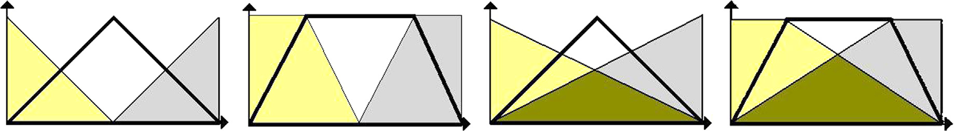

Fig. 1. Examples of 2-Ruspini (a), 2-core (b), crown (c) and (d) core–crown partitions.

The unique-support property means that all fuzzy sets in a partition **A** on *�* share the same support, the universe of discourse itself; as a consequence, any element of domain *�* has positive membership to every fuzzy set in **A**. The non-level-cut-inclusion property means that no level cut of one fuzzy set in the partition is included in any of those of another fuzzy set in the same partition.

Let us now examine how some of these properties relate to each other. Except for the trivial case in which a CFP is formed by only one crisp set representing the universe of discourse itself, the additivity and the unique support properties are incompatible. Core-covering and additivity are also incompatible, except when a CFP is in fact a classical partition. CFPs that obey unique-support cannot obey non-level-cut-inclusion, since at least the support of any fuzzy set is included in the support of all other fuzzy sets in that partition. Finally, all additive CFPs also obey non-level-cut-inclusion, due to the normalization requirement in the CFP definition.

Using the properties above, some interesting types of CFPs can be defined [21]:

• *Ruspini 2-CFPs*: are 2-CFPs and obey additivity.

• *crown CFPs*: obey unique-support.

• *core 2-CFPs*: are 2-CFPs and obey core-covering.

• *core–crown CFPs*: obey core-covering and unique-support.

Note that any core–crown partition is *n-CFP* with *n* = |*A*|. As a consequence, core 2-CPFs can also be core–crown, but only when the partition has at most two fuzzy sets.

In the remaining of the text, we also refer to Ruspini and core 2-CFPs as 2-Ruspini and 2-core, for short. Fig. 1 illustrates a 2-Ruspini, a 2-core, a crown, and a core–crown CFP with three fuzzy sets (the central fuzzy set in each partition is highlighted).

Ruspini 2-CPFs are related to *strong partitions* [20], also known as *Ruspini partitions*, in which additivity is required but not convexity. These partitions are very much used for automatic clustering of data such as in fuzzy C-means [2]. Crown CPFs are related the partitions used in [14], which obey a weaker kind of unique support property. These CFPs are useful to avoid inconsistencies in fuzzy rule bases that model rules with residuated implication operators. Core 2-CPFs are related to what is called a *T-partition* by some authors (see e.g. [4]), which is core-covering and is such that an element of the domain has positive membership to at most two fuzzy sets in the partition.

**4. Order compatible fuzzy relations**

We now propose the use of a fuzzy relation that is compatible with a given total order and models a notion of similarity for which transitivity does play a role, as discussed in Section 1 [21].

Let *S* : *�*2→ [0*,* 1] be a fuzzy binary relation and (*�,* ⪯) be a total order. Formally, *S* is an *OCFR* with respect to a total order (*�,* ⪯) (OCFR⪯ or OCFR, for short), when it obeys the following properties:  
• *reflexivity* and *symmetry* (see Section 2);  
• ∀*x, y, z* ∈ *�*, if *x* ⪯ *y* ⪯ *z*, then *S*(*x, z*)≤ min(*S*(*x, y*)*, S*(*y, z*)) (*compatibility with total order* (*�,* ⪯), or ⪯*-compatibility* for short).

of something being similar to something else as opposed of being distant, in the usual (Euclidean) sense (see also [18] The second property was called *compatibility with the Euclidean distance* in [9], for *�* = ℜ. It grasps the meaning

for the same property in reciprocal preference relations context).

*S. Sandri, F.T. Martins-Bedê / Fuzzy Sets and Systems 239 (2014) 91*–*103*  95

An example of a relation that is *T*-transitive but not compatible with a total order is the reflexive and symmetric

relation *S*′on *�* = {*a, b, c*}, with *a < b < c*, for which *S*′(*a, c*) = 1 and *S*′(*a, b*) = *S*′(*b, c*) = 0. An example of a relation that is compatible with a total order, but not *T*-transitive for any *T*-norm ⊤, is the reflexive and symmetric relation *S*′on *�*, for which *S*′(*a, c*) *< S*′(*a, b*) *< S*′(*b, c*) = 1. *T*-transitivity and compatibility with total order are not mutually exclusive properties, however. For instance,

*S*(*x, y*) = 1 − |*x* − *y*| on [0*,* 1] is both *T*-transitive for some *T*-norms (e.g. Lukasiewicz) and compatible with to-tal order ([0*,* 1]*,* ≤). Let us now contrast compatibility with total order and anti-transitivity properties. In the classical framework, a

relation *R* is anti-transitive when ∀*x, y, z* ∈ *�*, if (*x, y*) ∈ *R* and (*y, z*) ∈ *R*, then (*x, z*) */*∈ *R*.

Let ⊤ be a *T*-norm. Let *anti-T-transitivity* be defined as ∀*x, y, z* ∈ *�*, *S*(*x, z*) *<* ⊤(*S*(*x, y*)*, S*(*y, z*)). Then, by definition, when (*�,* ⪯) is a total order, anti-*T*-transitivity implies ⪯ -compatibility. The converse is however not true, it suffices to take as counterexample a relation *S*′, compatible with a given total order (*�,* ⪯), for which ∃*a, b, c* ∈ *�*, *S*′(*a, c*) = *S*′(*a, b*) = *S*′(*b, c*).

[0*,* 1] be a fuzzy binary relation described below. Let us now examine how OCFRs are related to some approaches in the literature, using our notation. Let *S* : *�*2→

• *S* is an *I-fuzzy equivalence relation* in *�* [13] when it is reflexive, symmetric and ∀*x, y, z* ∈ *�, S*(*x, z*)≤*I*(*S*(*x, y*), *S*(*y, z*)), where *I* is a mapping *I* : [0*,* 1]2→ [0*,* 1] such that *I*(1*,* 0) = 0 and *I*(0*,* 0) = *I*(0*,* 1) = *I*(1*,* 1) = 1.• *S* is a *nearness relation* in *�* [12] when it is reflexive, symmetric and ∀*x, y, z* ∈ *�*, if *x*≤*y*≤*z* then *S*(*x, z*)≤*S*(*x, y*).• *S* is a [0, 1]-*valued equality relation* in *�* [5] when it is symmetric, obeys a weak form of reflexivity, defined as ∀*x, y, z* ∈ *�*, *S*(*x, y*)≤ min(*S*(*x, x*)*, S*(*y, y*)), and ∀*x, y, z* ∈ *�, S*(*x, z*)≥*S*(*x, y*) + *S*(*y, z*) − *S*(*y, y*).

• *S* is a (*g, d*)*-resemblance relation* in *�* [5] when it is reflexive, symmetric and ∀*u, x, y, z* ∈ *�*, *d*(*g*(*x*)*, g*(*y*))≤*d*(*g*(*z*), *g*(*u*)) implies *S*(*x, y*)≥*S*(*z, u*), where *g* : *�* → *M* and *d* : *M*2→ [0*,* 1] are such that ∀*x, y, z* ∈ *M*, *d*(*x, x*) = 0, *d*(*x, y*) = *d*(*y, x*) and *d*(*x, z*)≤*d*(*x, y*) + *d*(*y, z*).

Let us now consider a total order ({1, 2, 5}, ≤). Let *Sabc* : {1*,* 2*,* 5} → [0*,* 1] denote reflexive and symmetric relations which are such that *Sabc*(1*,* 5) = *a*, *Sabc*(1*,* 2) = *b* and *Sabc*(2*,* 5) = *c*. For example, for *S*100, we have *S*100(1*,* 5) = 1, *S*100(1*,* 2) = 0 and *S*100(2*,* 5) = 0. We can classify these relations as

• *Sabc* is an OCFR≤, when *a*≤ min(*b, c*),  
• *Sabc* is an *I*-fuzzy equivalence relation, when *a*≤*I*(*b, c*),  
• *Sabc* is a nearness relation, when *a*≤*b*,  
• *Sabc* is a [0,1]-valued equality relation, when *a*≥*b* + *c* − 1,  
• *Sabc* is a (I*, abs*)-resemblance relation with *M* = *�*, *g*(*x*) = I(*x*) = *x* and *d*(*x, y*) = *abs*(*x, y*) = |*x* − *y*|, when *a*≤*c*≤*b*.

Table 1 brings a classification of relations *Sabc* with respect to the above approaches.

We see in Table 1 that these formalisms are not equivalent to each other. Indeed, we have:

• except for *S*100, *S*101 and *S*110, all *Sabc* are OCFRs,  
• except for *S*110, all *Sabc* are *I*-fuzzy equivalence relations,• except for *S*100 and *S*101, all *Sabc* are nearness relations,

Table 1

Relations *Sabc* : {1*,* 2*,* 5} → {0*,* 1}; *Sabc*(1*,* 5) = *a*, *Sabc*(1*,* 2) = *b* and *Sabc*(2*,* 5) = *c*.

|  |  |  |  |  |  |
| --- | --- | --- | --- | --- | --- |
| *Sabc* | OCFR≤ | *I*-fuzzy equiv. | Nearness | [0,1]-Valued equal. | (I*, abs*)-resemb*.* |
| *S*000 | y | y | y | y | y |
| *S*001 | y | y | y | y | n |
| *S*010 | y | y | y | y | y |
| *S*011 | y | y | y | n | y |
| *S*100 | n | y | n | y | n |
| *S*101 | n | y | n | y | n |
| *S*110 | n | n | y | y | n |
| *S*111 | y | y | y | y | y |

96 *S. Sandri, F.T. Martins-Bedê / Fuzzy Sets and Systems 239 (2014) 91*–*103*

• except for *S*011, all *Sabc* are [0,1]-valued equality relations and• only *S*000, *S*010, *S*011, *S*111 are (I*, abs*)-resemblance relations.

Relations *Sabc* are *T*-indistinguishable operators when *a*≥ min(*b, c*). Therefore, in the particular case of these relations, since they are mappings from *�* to {0*,* 1}, they are equivalent to [0,1]-valued equality relations. That is however not true for all fuzzy relations, as when [0*,* 1] is used instead of {0*,* 1}; for example, for a relation *Sabc* in which *a* = 0 and *b* = *c* = 0*.*6. We can see from Table 1 that, as expected, OCFRs are closely related to (*g, d*)-resemblance relations. Both relations

capture the concept that two elements in a domain are more similar, the closer they are in that universe. However,

(*g, d*)-resemblance relations take into account the exact positions of any two elements in the domain, as measured

by *g* and *d*, whereas in OCFRs we are only interested in the order, which explains why *S*001 is an OCFR but not a

(*g, d*)-resemblance relation. The following proposition verifies other relationships between the formalisms addressed

here.

**Proposition 1.** *Every* OCFR≤ *is a nearness relation and an I-fuzzy equivalence relation*. *Moreover*, *every* (*g, d*)-*resemblance relation S*, *with g* = I, *is an* OCFR≤.

**Proof.** Every OCFR≤ is a nearness relation, since ∀*x, y, z* ∈ *�*, when *x*≤*y*≤*z*, *S*(*x, z*)≤ min(*S*(*x, y*)*, S*(*y, z*))≤*S*(*x, y*). We prove that every OCFR≤ is an *I*-fuzzy equivalence relation by choosing *I* as Gödel implication: ∀*a, b* ∈ [0*,* 1], *IG*(*a, b*) = 1 when *a*≤*b*, and *IG*(*a, b*) = *b*, otherwise. Indeed, *IG*(*S*(*x, y*)*, S*(*y, z*))≥ min(*S*(*x, y*)*, S*(*y, z*))≥*S*(*x, z*),∀*x, y, z* ∈ *�*.

Since (*g, d*)-resemblance uses an extra argument *u*, we only have to verify whether *S* is an OCFR in all positions that To prove that every (*g, d*)-resemblance relation *S*, with *g* = I, is an OCFR, let us consider a fixed triple *x*≤*y*≤*z*.

*u* can take relative to *x, y* and *z*.

1. If *u*≤*x*, considering the triples that can be constructed using distinct values {*u, x, y, z*}, we have to prove that: (a) *S*(*u, y*)≤ min(*S*(*u, x*)*, S*(*x, y*)),   
(b) *S*(*u, z*)≤ min(*S*(*u, x*)*, S*(*x, z*)),   
(c) *S*(*u, z*)≤ min(*S*(*u, y*)*, S*(*y, z*)) and   
(d) *S*(*x, z*)≤ min(*S*(*x, y*)*, S*(*y, z*)).

Since *d*(*u, x*) + *d*(*x, y*)≤*d*(*u, y*), we have *d*(*u, x*)≤*d*(*u, y*) and *d*(*x, y*)≤*d*(*u, y*). In consequence, we obtain both *S*(*u, x*)≥*S*(*u, y*) and *S*(*x, y*)≥*S*(*u, y*), which proves case (a). Cases (b)–(d) are proved in the same manner. 2. If either *x*≤*u*≤*y* or *y*≤*u*≤*z* or *z*≤*u*, we prove that *S* is an OCFR≤ using a similar reasoning as when *u*≤*x*. �

In the next sections, we study how to generate an OCFR⪯ from a CFP⪯.

**5. Generating OCFRs from CFPs**

A very important result concerning the transformation between a collection of fuzzy sets and a fuzzy relation is the

Representation Theorem for *T*-indistinguishable operators [29] (see also [19]).

Let *S* be a fuzzy relation on a set *�*. The representation theorem states that *S* is a *T*-indistinguishability relation iff

there exists a family **A** = {*A*1*,* ... *, Ak*} of fuzzy subsets of *�*, called a *generating family* of *S*, such that

∀*x, y* ∈ *�,*  *S*⊤(*x, y*) = inf *BI*⊤(*Ai*(*x*)*, Ai*(*y*))*,*

where ⊤ is a continuous *T*-norm. Therefore, for every collection of fuzzy sets, one can use the representation theorem to generate a *T*-indistinguishable

relation. For example, applying the Lukasiewicz biresiduated operator on a partition **A**, we obtain the ⊤*L*-indis-tinguishable relation *SL*, given as

∀*x, y* ∈ *�,*  *SL*(*x, y*) = inf 1 − |*Ai*(*x*) − *Ai*(*y*)|*.*

In the following, we study the means to guide the generation of relations from partitions, when *T*-indistinguishability

is not required.

*S. Sandri, F.T. Martins-Bedê / Fuzzy Sets and Systems 239 (2014) 91*–*103*  97

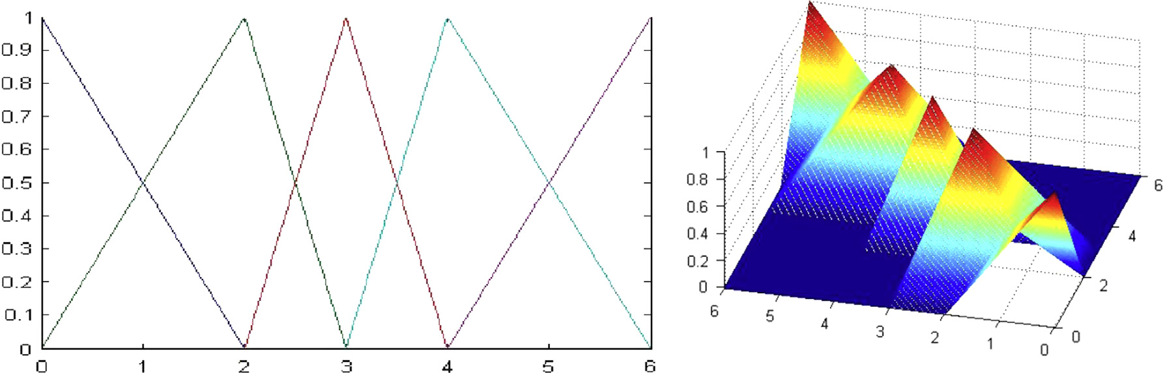

Fig. 2. Example of a Ruspini 2-CFP **A** and its corresponding *S*∗relation.

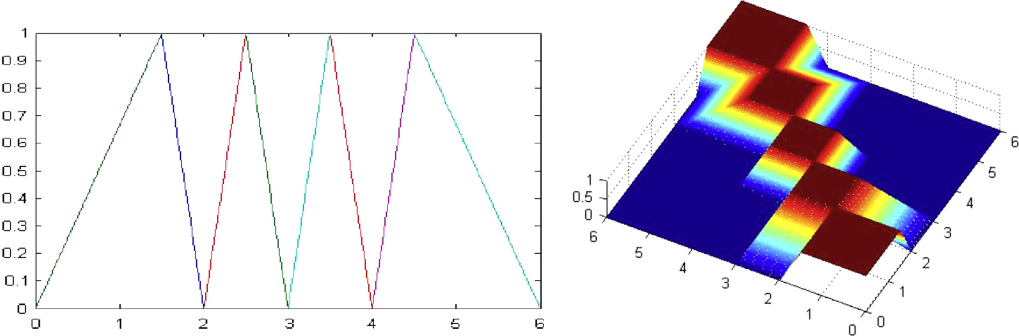

Fig. 3. Example of a core 2-CFP **A** and its corresponding *S*∗relation.

Transformations between unrestricted collections of fuzzy sets and unrestricted fuzzy relations on a finite domain

*�* were proposed in [25]. Let **A** = {*A*1*,* ... *, Ak*} be a collection of fuzzy sets on *�*. The generation of a fuzzy relation from a collection of fuzzy sets proposed in [25] is defined as

∀*x, y* ∈ *�,*  *S*∗(*x, y*) = sup *i*  min(*Ai*(*x*)*, Ai*(*y*))*.*

2-Ruspini, crown, 2-core and core–crown, along with their derived *S*∗. In Figs. 2, 3, 4, and 5 we present examples of CFPs compatible with a total order (*�,* ≤), which are, respectively,

Before moving further, let us verify a property of *S*∗that is important in our framework [21].

**Proposition 2.** *Let* (*�,* ⪯) *be a total order and let* **A** *be a* CFP⪯. *Let S*∗*be derived from* **A** *as given as above*. *We then have*

*S*∗*is* ⪯ -*compatible.*

*In other words*, *if x* ⪯ *y* ⪯ *z*, *then* min(*S*∗(*x, y*)*, S*∗(*y, z*))≥*S*∗(*x, z*).

**Proof.** It is enough to check that, for each *i*, we have both (I) min(*Ai*(*x*)*, Ai*(*y*))≥ min(*Ai*(*x*)*, Ai*(*z*)) and (II) min(*Ai*(*y*),

for the following cases, regarding the possible orderings among *Ai*(*x*), *Ai*(*y*) and *Ai*(*z*): *Ai*(*z*))≥ min(*Ai*(*x*)*, Ai*(*z*)). Moreover, since the *Ai*’s are convex fuzzy sets, one has only to check that (I) and (II) hold

1. *Ai*(*x*)≤*Ai*(*y*)≤*Ai*(*z*),   
2. *Ai*(*x*)≤*Ai*(*y*)*, Ai*(*y*)≥*Ai*(*z*),   
3. *Ai*(*x*)≥*Ai*(*y*)≥*Ai*(*z*).

98 *S. Sandri, F.T. Martins-Bedê / Fuzzy Sets and Systems 239 (2014) 91*–*103*

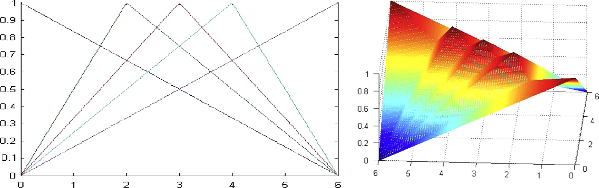

Fig. 4. Example of a crown CFP **A** and its corresponding *S*∗relation.

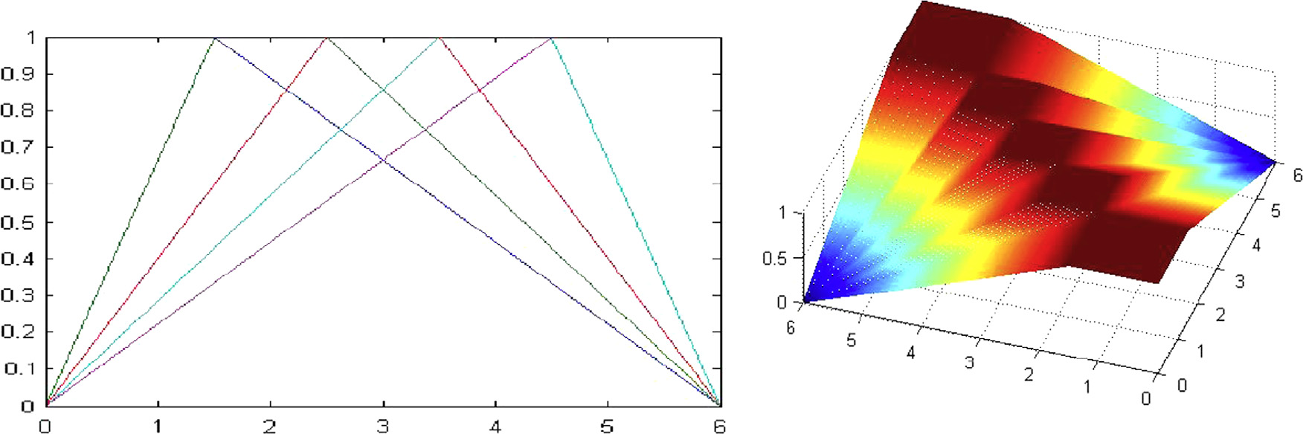

Fig. 5. Example of a core–crown CFP **A** and its corresponding *S*∗relation.

For example, for case 2, we see that min(*Ai*(*y*)*, Ai*(*z*)) = *Ai*(*z*)≥ min(*Ai*(*x*)*, Ai*(*z*)), which proves condition (II). The other possibilities are verified in a similar manner. �

An OCFR⪯ is by definition reflexive, symmetric and ⪯-compatible. As we have seen in Proposition 1, relation *S*∗derived from a CFP⪯ **A** is ⪯ -compatible. From its definition, we see that relation *S*∗is also symmetric. However, depending on the kind of CPF **A**, *S*∗is not necessarily reflexive. In the following, we prove that the reflexive closure

of *S*∗is an OCFR⪯.

**Proposition 3.** *Let* (*�,* ⪯) *be a total order and S*∗*be the relation derived from a* CFP⪯**A** = {*A*1*,* ... *, An*}. *Let Sid denote the identity fuzzy relation*, *given by*

∀*x, y* ∈ *�,*  *Sid*(*x, y*) =�1 *i f x* = *y*

0 *otherwise*

*The reflexive closure of S*∗, *given by*

∀*x, y* ∈ *�,*  *S*∗*id*(*x, y*) = max(*S*∗(*x, y*)*, Sid*(*x, y*))

*is an* OCFR⪯.

**Proof.** Toprovethat *S*∗*id*is⪯ -compatibleweonlyhavetoverifyexpressionmin(max(*S*∗(*x, y*), *Sid*(*x, y*)),max(*S*∗(*y, z*), *Sid*(*y, z*)))≥ max(*S*∗(*x, z*)*, Sid*(*x, z*)), with *x* ⪯ *y* ⪯ *z*, by checking the three possible cases *x* = *y*, *y* = *z* and

*S. Sandri, F.T. Martins-Bedê / Fuzzy Sets and Systems 239 (2014) 91*–*103*  99

reflexive, by definition. Therefore, relation *S*∗*x* = *y* = *z*. Since closure does not interfere with symmetry, *S*∗*id*derived from an CFP⪯ **A** is an OCFR⪯. �*id*inherits this property from *S*∗. Moreover, *S*∗*id*is

For both 2-core and core–crown CPFs, the derived *S*∗is itself reflexive, because for any element of *�*, there exists a fuzzy set in **A** for whom the element has membership degree equal to 1. Therefore, for these CFPs, *S*∗= *S*∗*id*, and thus *S*∗is an OCFR⪯. However, this is not always the case for both crown CPFs and Ruspini 2-CPFs, since it is possible that relation *S*∗generated from these CFPs is not reflexive (see Figs. 2 and 4).

We propose to use the following two properties to guide the transformation from a CFP **A** to a fuzzy relation *S*, both defined on *�*:  
• ∀*Ai* ∈ **A***,* ∀*c* ∈ *core*(*Ai*)*,* ∀*x* ∈ *�, S*(*c, x*) = *S*(*x, c*) = *Ai*(*x*) (*core-restrictivity*);  
• ∀*x, y* ∈ *�, S*(*x, y*)≥*S*∗(*x, y*) = sup*i* min(*Ai*(*x*)*, Ai*(*y*)) (*level-cut-compatibility*).

We say that a fuzzy relation *S* is *core–level-cut-compatible* with a fuzzy partition **A** defined in the same domain *�*, if *S* is both core-restrictive and level-cut-compatible with **A**.

Core-restrictivity states that the “slice” from *S*, corresponding to an element *c* at the core of a set *Ai* (the column of element *c* in [19]), is *exactly* the same as *Ai*. Level-cut-compatibility ensures that any two elements of *�* that belong to level cut [*Ai*]*�* of a fuzzy set *Ai* in **A** will also belong to level cut [*S*]*�* of relation *S*. Both core-restrictivity and level-cut-compatibility ensure that partition **A** is a subset of the columns of *S*.

In the following, we prove some results about core–level-cut-compatibility with respect to relations derived from a CFP⪯ **A**.

**Proposition 4.** *Let* (*�,* ⪯) *be a total order*. *The finest* OCFR⪯ *core–level-cut-compatible with a 2-Ruspini* CFP⪯ **A** *on� is relation S*∗*idgenerated from* **A**.

**Proof.** To prove that *S*∗is core-restrictive in relation to a Ruspini 2-CFP **A**, for any given *A*0 ∈ **A** and *c*0 ∈ *core*(*A*0), we should have *S*∗(*x, c*0) = *S*∗(*c*0*, x*) = *A*0(*x*). Indeed, we have *S*∗(*x, c*0) = max(min(*A*0(*x*), *A*0(*c*0)), sup*i* � 0 min(*Ai*(*x*), *id*. *Ai*(*c*0))) = max(*A*0(*x*)*,* 0) = *A*0(*x*). The result also holds for *S*∗By definition, *S*∗is the finest relation that is level-cut-compatible with any CFP. In consequence, *S*∗is the finest core–level-cut-compatible relation with a 2-Ruspini CFP. By Proposition 3, *S*∗*id*is an OCFR⪯. Therefore, since the only difference between *S*∗and *S*∗  
*id*is that the latter is reflexive, *S*∗*id*is the finest OCFR⪯ core–level-cut-compatible with **A**. �  
**Proposition 5.** *Given a Ruspini 2-CFP* **A** *on �*, *let S be any fuzzy binary relation that is core–level-cut-compatible with partition* **A**. *Then supp*(*S*) = *supp*(*S*∗).

**Proof.** Since *S*∗is finer than *S*, i.e. *S*≥*S*∗, we have *supp*(*S*∗) ⊆ *supp*(*S*). To show the other inclusion, suppose *x, y* are such that *S*∗(*x, y*) = 0. Since **A** covers *�*, there exists *Ai* ∈ **A** such that *Ai*(*x*) *>* 0. But by definition of *S*∗, if *Ai*(*x*) *>* 0 then *Ai*(*y*) = 0. Since **A** is a 2-Ruspini partition, *Ai*(*x*) = 1. Therefore, *S*(*x, y*) = *Ai*(*y*) = 0. � Proposition 4 gives a lower bound on the core–level-cut-compatible OCFRs that can be derived from a Ruspini 2-CFP **A**, considering a total order (*�,* ⪯). Proposition 5 gives an upper bound for the support of a fuzzy relation *S* derived from a Ruspini 2-CPF.

**Proposition 6.** *Let* (*�,* ⪯) *be a total order and* **A** *be a* CFP⪯. *When* **A** *is either crown*, 2-*core or core–crown CPFs*, *the derived S*∗*idis not necessarily core–level-cut-compatible with* **A**.

**Proof.** We first prove that there exists a core–crown CFP **A**, from which the derived *S*∗relation is not core–level-cut-compatible with **A**.

Let **A***xy* = {*Ax, Ay*} be a core 2-CFP, where both *Ax* and *Ay* are trapezoids. Let us also suppose, without loss of generality, that there exists two elements *cx* and *cy* in *�*, such that *cx* ∈ *core*(*Ax*), *cy* ∈ *core*(*Ay*) and *Ay*(*cx*) *> Ax*(*cy*). For core-restrictivity to hold, we should have (a) ∀*�* ∈ *�*, *S*∗(*cx, �*) = *S*∗(*�, cx*) = *Ax*(*�*) and (b) ∀*�* ∈ *�*, *S*∗(*cy, �*) = *S*∗(*�, cy*) = *Ay*(*�*).Letusfirstconsider(a).Wehave∀*�* ∈ *�, S*∗(*cx, �*) = *S*∗(*�, cx*) = max(min(*Ax*(*�*),

100 *S. Sandri, F.T. Martins-Bedê / Fuzzy Sets and Systems 239 (2014) 91*–*103*

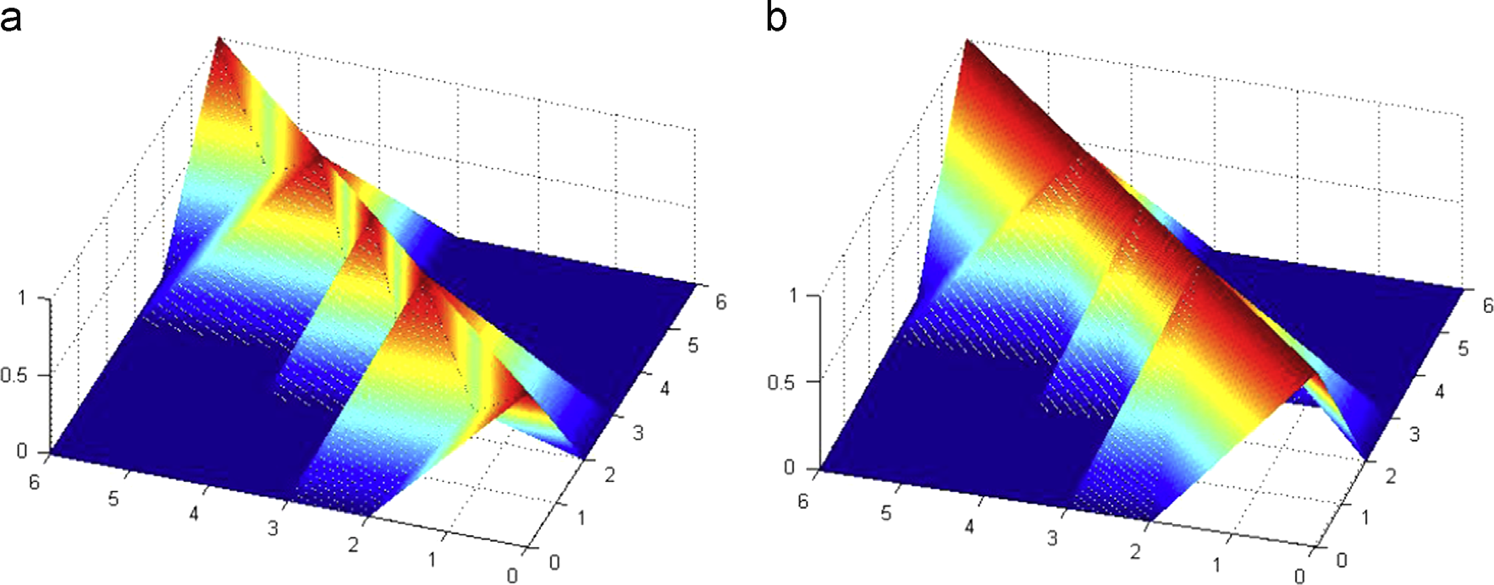

Fig. 6. Fuzzy relations derived from a 2-Ruspini CFP: (a) *S*∗*id*and (b) *S*+.

*Ax*(*cx*)), min(*Ay*(*�*)*, Ay*(*cx*))) = max(*Ax*(*�*), min(*Ay*(*�*)*, Ay*(*cx*))). When we apply this formula to *�* = *cy*, we should obtain *Ax*(*cy*) as result. Instead, we have *S*∗(*cx, cy*) = *S*∗(*cy, cx*) = max(*Ax*(*cy*)*, Ay*(*cx*)) = *Ay*(*cx*) *> Ax*(*cy*). Therefore, core-restrictivity does not hold for **A***xy*, which proves that *S*∗derived from a core–crown CFP is

not necessarily core–level-cut-compatible with that CFP. Since here *S*∗

Finally, since **A***xy* is both a crown CPF and a core 2-CPF, the result also holds for these two types of CPFs. �*id*= *S*∗, the result is valid for *S*∗*id*.

In the following section we propose a transformation method that is particularly useful for 2-Ruspini CFPs.

**6. Proposal of a method to obtain OCFRs from CFPs**

In this section we propose a transformation method to obtain fuzzy relations from CFPs. We also show that the

application of the proposed transformation on a 2-Ruspini CPF **A** generates an OCFR core–level-cut-compatible

with **A**.

[0*,* 1] from **A** as Let (*�,* ⪯) be a total order and **A** = {*A*1*,* ... *, Ak*} be a CFP⪯. We propose to generate a fuzzy relation *S*+: *�*×*�* →

*S*+(*x, y*) =�0

*SL*(*x, y*) otherwise   
 if *S*∗(*x, y*) = 0

We see that, if *x* and *y* are not related in *S*∗, they are also not related in *S*+. Relations *S*∗*id*and *S*+ generated from our

2-Ruspini CFP can be compared in Fig. 6.

We recall that

∀*x, y* ∈ *�,*  *SL*(*x, y*) = inf 1 − |*Ai*(*x*) − *Ai*(*y*)|

is a *T*-indistinguishable relation, where ⊤*L* is the Lukasiewicz *T*-norm (see Section 5). Note, however, that *S*+is not always ⊤*L*-indistinguishable. For example, considering the partition depicted in Fig. 2 with *x* = 1 and *y* = 5, we have *S*+(1*,* 5) = *S*∗(1*,* 5) = 0, whereas *SL*(1*,* 5) = 0*.*5.

with *A* (Propositions 8 and 9). Weprovebelowthat *S*+appliedtoa2-RuspiniCFP⪯ **A**isanOCFR⪯ (Proposition7)thatiscore–level-cut-compatible

**Proposition 7.** *Let* (*�,* ⪯) *be a total order and* **A** *be a 2-Ruspini* CFP⪯. *Relation S*+*derived from* **A** *is an* OCFR⪯, *i.e*., *it is reflexive*, *symmetric and* ⪯ -*compatible*.

*S. Sandri, F.T. Martins-Bedê / Fuzzy Sets and Systems 239 (2014) 91*–*103*  101

**Proof.** By the definition of *S*+and *SL*, we see that *S*+is reflexive and symmetric. To prove ⪯ -compatibility, we have to verify that

∀*x, y, z* ∈ *�* if *x* ⪯ *y* ⪯ *z* then *S*+(*x, z*)≤ min(*S*+(*x, y*)*, S*+(*y, z*))*.*

the three possible cases. Since **A** is a 2-Ruspini CFP⪯, each element in *�* has non-null membership to at most 2 fuzzy sets in **A**. We examine

• *Case* 1: For all *Ai* ∈ **A**, min(*Ai*(*x*)*, Ai*(*z*)) = 0.

In this case we have *S*+(*x, y*) = *S*∗(*x, z*) = 0≤ min(*S*+(*x, y*)*, S*+(*y, z*)).

• *Case* 2: There exists *B* ∈ **A** such that *S*∗(*x, z*) = min(*B*(*x*)*, B*(*z*)) *>* 0 and for all *Ai* ∈ **A** *Ai* � *B*, min(*Ai*(*x*), *Ai*(*z*)) = 0.

If *x* and *z* may belong to the support of other fuzzy sets than *B*, then *x* ∈ *supp*(*B*−) ∩ *supp*(*B*) and *z* ∈ *supp*(*B*) ∩*supp*(*B*+), where *B*−and *B*+are fuzzy sets in **A** adjacent to *B*, to its left and right, respectively. Moreover, *B*−(*x*) = 1 − *B*(*x*), *B*−(*y*) = 1 − *B*(*y*), *B*+(*y*) = 1 − *B*(*y*) and *B*+(*z*) = 1 − *B*(*z*).

Thus *SL*(*x, z*) = min(inf *Ai*∈{*B*−*,B,B*+} 1−|*Ai*(*x*)−*Ai*(*z*)|,inf *Ai /*∈{*B*−*,B,B*+} 1−|*Ai*(*x*)−*Ai*(*z*)|) = min(*B*(*x*)*, B*(*z*)*,* 1−|*B*(*x*) − *B*(*z*)|). In a similar manner, and considering that *B* is convex, we obtain *SL*(*x, y*) = 1 − |*B*(*y*) − *B*(*x*)| = *B*(*x*) + 1 − *B*(*y*) and *SL*(*y, z*) = 1 − |*B*(*y*) − *B*(*z*)| = *B*(*z*) + 1 − *B*(*y*).

Without loss of generality, let us suppose *B*(*x*)≥*B*(*z*). We finally obtain *SL*(*x, z*) = *B*(*z*)≤*B*(*z*) + 1 − *B*(*y*) = min(*SL*(*x, y*)*, SL*(*y, z*)),

• *Case* 3: There exists two contiguous fuzzy sets *B*1*, B*2 in partition **A** such that min(*B*1(*x*)*, B*1(*z*)) *>* 0 and min(*B*2(*x*), *B*2(*z*)) *>* 0, and for all *Ai* ∈ **A** such that *Ai* � *B*1 and *Ai* � *B*2, min(*Ai*(*x*)*, Ai*(*z*)) = 0.

As previously, we just have to check that *SL*(*x, z*)≤ min(*SL*(*x, y*)*, SL*(*y, z*)).

But ∀*w*1*, w*2 ∈ *supp*(*B*1) ∩ *supp*(*B*2), *SL*(*w*1*, w*2) = min(1 − |*B*1(*w*1) − *B*1(*w*2)|, 1 − |*B*2(*w*1) − *B*2(*w*2)|, inf *Ai /*∈{*B*1*,B*2} 1 − |*Ai*(*w*1) − *Ai*(*w*2)|), and since *B*2(*w*) = 1 − *B*1(*w*)*,* ∀*w* ∈ *supp*(*B*1) ∩ *supp*(*B*2), *SL*(*w*1*, w*2) = 1 − |*B*1(*w*1) − *B*1(*w*2)|.

Given that *B*1 is convex, and supposing that *B*1 is to the left of *B*2 in **A**, we have *B*1(*x*)≥*B*1(*y*)≥*B*1(*z*). We then which completes the proof. �obtain *SL*(*x, z*) = 1 − |*B*1(*x*) − *B*1(*z*)|≤ min(1 − |*B*1(*x*) − *B*1(*y*)|, 1 − |*B*1(*y*) − *B*1(*z*)|) = min(*SL*(*x, y*)*, SL*(*y, z*)),

**Proposition 8.** *Let* (*�,* ⪯) *be a total order and* **A** *be a* CFP⪯ 2-*Ruspini*. *Relation S*+(*x, y*) *is core-restrictive with A*.

**Proof.** Let *A*0 be a fuzzy term in *A* and *c*0 ∈ *core*(*A*0). We have to prove that ∀*x* ∈ *�*, we have *S*+(*c*0*, x*) = *S*+(*x, c*0) = *A*0(*x*). There are two possibilities for *x*:

1. If *x /*∈ *supp*(*A*0), we have *S*+(*c*0*, x*) = *S*∗(*c*0*, x*) = 0 = *A*0(*x*).

2. If *x* ∈ *supp*(*A*0), we have *S*∗(*c*0*, x*) *>* 0 and thus *S*+(*c*0*, x*) = *SL*(*c*0*, x*). Since **A** is a 2-Ruspini partition, we have at most one fuzzy set *A*′in **A** such that *x* ∈ *supp*(*A*0) ∩ *supp*(*A*′). Therefore, we have *S*+(*c*0*, x*) = min(1 − |*A*0(*c*0) − *A*0(*x*)|*,* 1 − |*A*′(*c*0) − *A*′(*x*)|, inf *Ai /*∈{*A*0*,A*′} 1 − |*Ai*(*c*0) − *Ai*(*x*)|). Since **A** is additive, we have *A*′(*x*) = 1 − *A*0(*x*) and also *Ai*(*x*) = 0*,* ∀*Ai /*∈ {*A*0*, A*′}. We thus obtain *S*+(*c*0*, x*) = *A*0(*x*). �

**Proposition 9.** *Let* (*�,* ⪯) *be a total order and* **A** *be a* CFP⪯ 2-*Ruspini*. *Relation S*+(*x, y*) *is level-cut-compatible with A*.

**Proof.** We have to prove that, given **A**, ∀*x, y* ∈ *�*, *S*+(*x, y*)≥*S*∗(*x, y*). Since **A** is 2-Ruspini, any two elements *x* and *y* in *�* are related through two contiguous normalized convex fuzzy sets in **A**. Let *B*1 and *B*2 be those two fuzzy sets,

where *B*1 is situated to the left of *B*2.

Using the same reasoning employed in part 3 of the proof of Proposition 7, we obtain *B*1(*x*)≥*B*1(*y*) and *S*+(*x, y*) = 1 − |*B*1(*x*) − *B*1(*y*)|. Moreover, we have *S*∗(*x, y*)= max(min(*B*1(*x*)*, B*1(*y*))*,* min(*B*2(*x*)*, B*2(*y*)), inf *Ai /*∈{*B*1*,B*2} min(*Ai*(*x*)*, Ai*(*y*))),whichreducesto *S*∗(*x, y*) = max(*B*1(*y*)*,* 1−*B*1(*x*))≤1−*B*1(*x*)+*B*1(*y*).Again,since *B*1(*x*)≥*B*1(*y*), we have *S*∗(*x, y*)≤1 − |*B*1(*x*) − *B*1(*y*)| = *S*+(*x, y*), which completes the proof. �

Relation *S*+is smoother than relation *S*∗*id*as shows the comparison between the relations depicted in Fig. 6, derived

from the 2-Ruspini CFP in Fig. 2. Fig. 7 compares the projection of *S*∗*id*and *S*+ for the same CFP. As expected, *S*∗*id*

102 *S. Sandri, F.T. Martins-Bedê / Fuzzy Sets and Systems 239 (2014) 91*–*103*

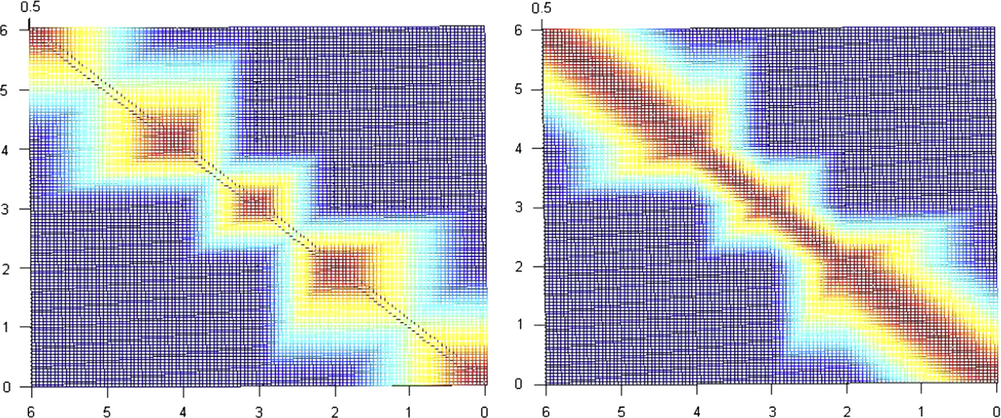

Fig. 7. Projection of *S*∗*id*and *S*+ for a 2-Ruspini partition.

is contained in *S*+, in the sense that ∀*x, y* ∈ *�, S*+(*x, y*)≥*S*∗than the one of *S*∗*id*, i.e. *S*+ does not preserve the support of *S*∗*id*(*x, y*). Moreover, we see that the support of *S*+ is larger *id*all over, but it preserves it in the points in which core-restrictivity plays a role.

**7. Conclusion**

Many applications use fuzzy relations that extend the concept of a classical relation to the fuzzy framework, to derive solutions to problems. Unfortunately, they are not very easily elicited from experts. On the other hand, one can elicit fuzzy partitions (collections of fuzzy sets) quite straightforwardly from experts, from which fuzzy relations can then be derived. This paper focuses on the generation of fuzzy relations from fuzzy partitions, to be used in applications in which any two elements in the universe of discourse are considered to be the more similar the closer they are in their domain.

In this work, first of all, we have discussed some properties that we find reasonable for a fuzzy partition. We proposed a large class of such partitions, called Convex Fuzzy Partitions with Respect to a Total Order (CFP), and related them to some fuzzy partitions found in the literature. We then proposed a particular class of fuzzy relations, named Order Compatible Fuzzy Relations (OCFR), that is capable to model that any two elements in the universe of discourse are considered to be the more similar the closer they are with respect to a given total order. We compared these relations to some other fuzzy relations from the literature.

We then discussed some compatibility properties that we consider reasonable when generating OCFRs from CFPs. Finally, we proposed a method that generates OCFRs from CFPs, that obey these properties for Ruspini partitions, a very important class of fuzzy partitions.

As future work, we intend to apply the transformation addressed here in applications, in particular, those based on the CBR framework proposed in [10]. This framework is itself based on the fuzzy CBR approach proposed in [1,26,27]. We also envision to use algorithms to learn the best CFP that generates the OCFR that is most suitable for a problem at hand.

**Acknowledgments**

The authors are deeply indebted to Lluis Godo for help with proofs of the propositions proposed in this paper, as well as thoughtful comments and suggestions. The authors would also like to thank Francesc Esteva and Bernard de Baets for pointing to pertinent literature, and Ana Paula A. Castro for help with the generation of the figures. Last but not least, the authors heartily thank anonymous reviewers and the volume editors for their comments and suggestions.

*S. Sandri, F.T. Martins-Bedê / Fuzzy Sets and Systems 239 (2014) 91*–*103*  103

**References**

[1] E. Armengol, F. Esteva, L. Godo, V. Torra, On learning similarity relations in fuzzy case-based reasoning, Trans. Rough Sets (2004) 14–32. [2] J.C. Bezdek, Pattern Recognition with Fuzzy Objective Function Algorithms, Plenum Press, New York, 1981.

[3] M. Das, M.K. Chakraborty, T.K. Ghoshal, Fuzzy tolerance relation, fuzzy tolerance space and basis, Fuzzy Sets Syst. 97 (3) (1998) 361–369. [4] B. De Baets, R. Mesiar, *T*-partitions, Fuzzy Sets Syst. 97 (2) (1998) 211–223.

[5] M. De Cock, E. Kerre, On (un)suitable fuzzy relations to model approximate equality, Fuzzy Sets Syst. 133 (2) (2003) 137–153. [6] J. Dobrakovová, Pseudometrics and fuzzy relations, J. Appl. Math. II (I) (2009) 375–380.

[7] I. Drummond, L. Godo, S. Sandri, Restoring consistency in systems of fuzzy gradual rules using similarity relations, in: Proceedings of SBIA’02, 2002, pp. 386–396.

[8] D. Dubois, A. Hadjali, H. Prade, Making fuzzy absolute and fuzzy relative orders of magnitude consistent, in: L.N.T. Bilgiç, B. de Baets, O. Kaynak (Eds.), Lecture Notes in Computer Science,vol. 2715/2003, 2003, pp. 694–701.

[9] I. Drummond, L. Godo, S. Sandri, Learning fuzzy systems with similarity relations, in: IFSA’03, Istanbul, Turkey. Lecture Notes in Computer Science, vol. 2715, Springer, 2003, pp. 516–523.

[10] T. Fanoiki, I. Drummond, S. Sandri, Case-based reasoning retrieval and reuse using case resemblance hypergraphs, in: WCCI’10, 2010, pp. 864–870.

[11] L. Godo, S. Sandri, A similarity-based approach to deal with inconsistency in systems of fuzzy gradual rules, in: IPMU’02, 2002, pp. 1655–1662. [12] V. Janis, Resemblance is a nearness, Fuzzy Sets Syst. 133 (2) (2003) 171–173.

[13] B. Jayaram, R. Mesiar, I-fuzzy relations and I-fuzzy partitions, Inf. Sci. 179 (2009) 1278–1297.

[14] H. Jones, B. Charnomordic, D. Dubois, S. Guillaume, Practical inference with systems of gradual implicative rules, IEEE Trans. Fuzzy Syst. 17 (1) (2009) 61–78.

[15] R. Lopez de Mantaras, L. Valverde, New results in fuzzy clustering based on the concept of indistinguishability relations, IEEE Trans. Pattern Anal. Mach. Intell. 10 (5) (1988) 754–757.

[16] R.D. Luce, Semi-orders and a theory of utility discrimination, Econometrica 24 (1956) 178–191.

[17] F.T. Martins-Bedê, L. Godo, S. Sandri, L.V. Dutra, C. Freitas, O.S. Carvalho, R.J.P.S. Guimares, R.S. Amaral, Classification of schistosomiasis prevalence using fuzzy case-based reasoning, in: Proceedings of IWANN’09, 2009, pp. 1053–1060.

[18] M. Rademaker, B. De Baets, Aggregation of monotone reciprocal relations with application to group decision making, Fuzzy Sets Syst. 184 (2011) 29–51.

[19] J. Recasens, Indistinguishability Operators, Modelling Fuzzy Equalities and Fuzzy Equivalence Relations, Studies in Fuzziness and Soft Computing, vol. 260, Springer, Berlin Heidelberg, 2011.

[20] R. Ruspini, A new approach to clustering, Inf. Control 15 (1969) 177–200.

[21] S. Sandri, F.T. Martins-Bedê, Order compatible fuzzy relations and their elicitation from general fuzzy partitions, in: Weiru Liu (Ed.), Symbolic and Quantitative Approaches to Reasoning with Uncertainty, Lecture Notes in Artificial Intelligence, vol. 6717, Proceedings of ECSQARU’2011 Belfast, 2011, pp. 640–650.

[22] R. Slowinski, D. Vanderpooten, A generalized definition of rough approximations based on similarity, IEEE Trans. Knowl. Data Eng. 12 (2) (2000) 331–335.

[23] H. Soldano, A. Viari, M. Champesme, Searching for flexible repeated patterns using a non-transitive similarity relation, Pattern Recognit. Lett. 16 (3) (1995) 233–246.

[24] A. Soto, J. Recasens, Modelling a linguistic variable as a hierarchical family of partitions induced by an indistinguishability operator, Fuzzy Sets Syst. 121 (3) (2001) 427–437.

[25] H. Thiele, A characterization of arbitrary Ruspini partitions by fuzzy similarity relations, in: Sixth IEEE International Conference on Fuzzy Systems, 1997, pp. 131–134.

[26] V. Torra, On the learning of weights in some aggregation operators: the weighted mean and owa operators, Math. Soft Comput. 6 (2–3) (2000). [27] V. Torra, Learning weights for the quasi-weighted means, IEEE Trans. Fuzzy Syst. 10 (5) (2002) 653–666.

[28] A. Tversky, Features of similarity, Psychol. Rev. 84 (4) (1977) 327–351.

[29] L. Valverde, On the structure of F-indistinguishability operators, Fuzzy Sets Syst. 17 (1985) 313–328.

[30] L. Zadeh, Similarity relations and fuzzy orderings, Inf. Sci. 3 (2) (1971) 177–200.